PRESS RELEASE

BOPP films continue to advance despite a constantly changing regional landscape.

BOPP films remain an integral part of global delivery of goods, and investment in capacity indicates continued confidence in its future

July 2026 — AMI Market Intelligence has released the new edition of its authoritative report offering a deep dive into the global BOPP films market, providing industry stakeholders and investors with a comprehensive analysis of market dynamics, technological advancements, and competitive pressures shaping the global market.

Whilst recent global macro-economic challenges such as inflationary pressures, economic instability, geopolitical conflict, and rising protectionism have impacted the BOPP market, AMI’s biax film research team has observed positive signs, and long-term growth prospects remain optimistic. Following a period of significant volatility in material consumption, driven first by the COVID-19-related surge in retail packaging demand and subsequently by widespread destocking, global demand for BOPP is expected to return to a more stable growth trajectory. Forecasts indicate a compound annual growth rate (CAGR) of more than 3% through to 2030.

Global investment in BOPP production capacity has continued throughout the five-year period to 2025. While AMI’s research indicates that the pace of capacity expansion is likely to slow over the next five years, output will increase from ever-wider and more efficient production assets. Thanks to BOPP’s strong position in many of its core applications; difficult to replace in essential food packaging and the expanding global snacks sector, and its greater penetration in retort pouches, emerging high-tech and new energy applications, BOPP films are well positioned for sustained long-term growth.

However, despite strong global growth prospects, the real story lies within the regions themselves

From rapidly expanding emerging markets to more mature economies navigating changing demand patterns, each region is following its own distinct path, highlighting both the complexity and resilience of the global market. 2025 saw a year of tariff chaos, yet inter-regional film trade still increased compared with previous years, in large part due to export-focused producers in Asia, offering large volumes of low-cost BOPP film.

AMI’s BOPP market report analyses eight separate world regions, plus a total world view. With a team of researchers conducting in-depth interviews across a vast network of producers, converters and suppliers of BOPP films, the findings reflect an unrivalled position to provide a holistic view of the trends in the market, and how they differ across world regions.

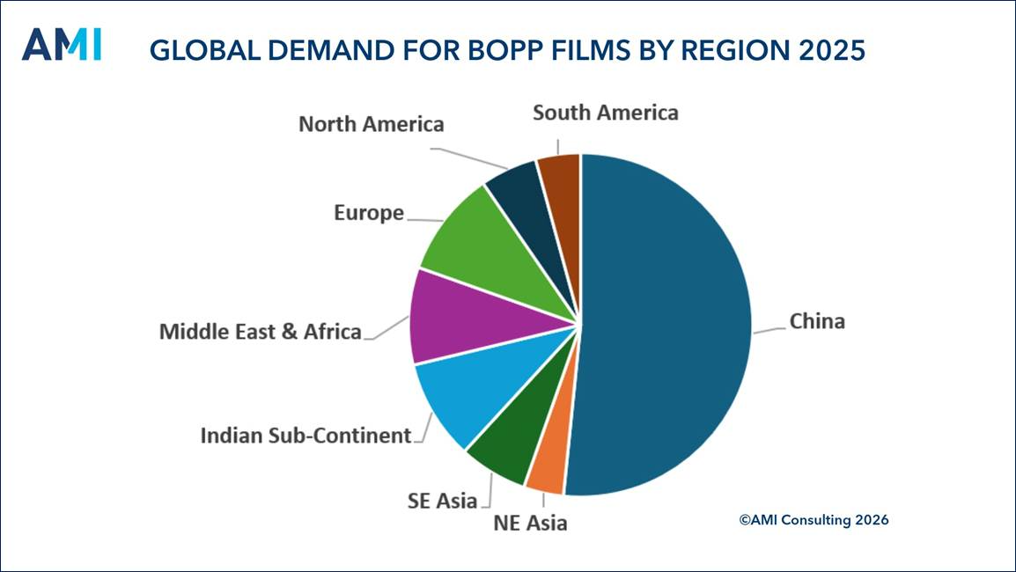

Each world region has different drivers for BOPP film use, and it is vital to understand these to grasp the size of current and future opportunities

The largest capacity increase is found in China, accounting for over half of line installations during 2020-2030. Whilst larger Chinese companies pursue export-led strategies, there is also an increased focus on domestic demand prospects in the country – growth from within.

The Indian Sub-Continent has the fastest demand growth, and per capita consumption is far below the global average. With its growing and youthful population, a large section of society with more disposable income and an increasing inclination to purchase packaged foods and snacks, confidence in future BOPP demand remains. The region has a low-cost manufacturing base and with experienced biax film producers expanding, both in the region and further afield, these and the new players that continue to enter the market need to be mindful of a looming supply/demand imbalance, with timing indicated by AMI data in the report.

In contrast, North East Asia’s population is declining and ageing. Although sophisticated packaging is an important element of consumer products in the region, production costs are high and producers struggle to compete with their lower-cost Asian neighbours and must rely on producing speciality BOPP grades, as well as technical films for non-packaging.

For the full picture and regional analysis from our expert consultants, the latest market report from AMI, titled "BOPP Films – the Global Market 2026", combines first-hand industry insight with data analysis to give a comprehensive picture of this important sector. The research, which was released in June 2026, gives investors and industry participants a thorough grasp of the competitive challenges, market dynamics, and industry development. If you are interested in hearing more about the report you can request your free proposal that contains more detail on the structure and findings included in the report by visiting our website, just click here.

